Hi Erica,

Here are my thoughts…I still would really like the ceremony and reception to be at different venues…if we find somewhere that has two amazing rooms that will give different “feels” then I’m open to it but I really do not want to risk having an outdoor ceremony and it raining.
That sounds great. I feel that we have the resources to be able to find two different venues for the ceremony and reception where we will be able to capture the exact vision that you have for your wedding. Below you’ll find my notes and answers to your questions. I have updated a few pictures based on what you’re looking for.
Ceremony:
- St. Regis Hotel:
  - For the outdoor area that is booked for a ceremony…what does that include? Is that the area pictured in this photo below? I was really really hoping they would be available for a ceremony. If this is what is booked, is it possible to re-create a look like this for the ceremony somewhere else?
The prior picture was unfortunately the outdoor courtyar. However, with the proper draping in the ballroom it would be possible to recreate this look. Here is a picture of the ballroom that is available.
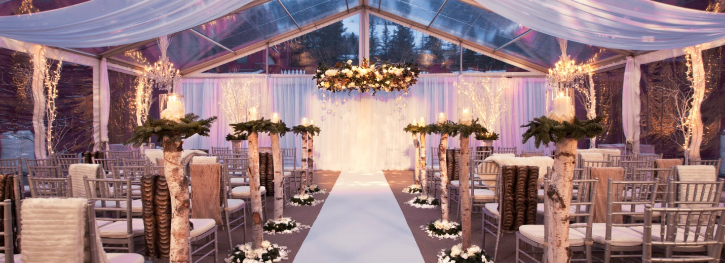
- Can we do a search for cute chapels and churches in Aspen as well? Just to keep all options open (I know I said something unique and we still want that but don’t want to limit ourselves if you know of somewhere better that is a chapel)
- The Art Museum looks awesome but the site fees are way too much. So it is out.
- The Theatre Aspen looks very cool from the outside but the indoor photos I’ve seen look fairly “blah.” What are your thoughts on this venue?
- The Wheeler/Stallard seems more reasonable cost wise but do they have any photos of the inside? We would not be using them for a reception and we would be wanting to get married indoors. Guest list of yes’s is still around 150 people.

Reception:
- Hotel Jerome:

Love the idea of guests staying here (room block) and using the Antler Bar as a place to have drinks and be introduced for the reception before going into the Grand Ballroom for the main reception (I like how Dan and Jeannie had the library at Saddleridge for drinks/signing of guest book and introduction, followed by reception upstairs)==would like something similar done at our wedding. If that is not an option, having champagne in a small/intimate room before the ceremony (which another friend of mine did at her wedding), would be nice as well. Though, we prefer the drinks before the reception.
- What does the Grand Ballroom look like at Hotel Jerome? I LOVE one picture in particular (includes classy antler chandeliers—top photo). Is this the Wheeler room or the Grand Ballroom?
- I am not a fan of a plain ballroom (bottom photo)…are the chandeliers something they added or do they come with the room?
- If we book the Grand Ballroom, does that include the Terrace along with it? I don’t want to run into any other wedding parties during our reception.

- St. Regis Ballroom:
It’s beautiful in this picture…if this is what it looks like or can look like then it and Hotel Jerome are becoming our top 2.

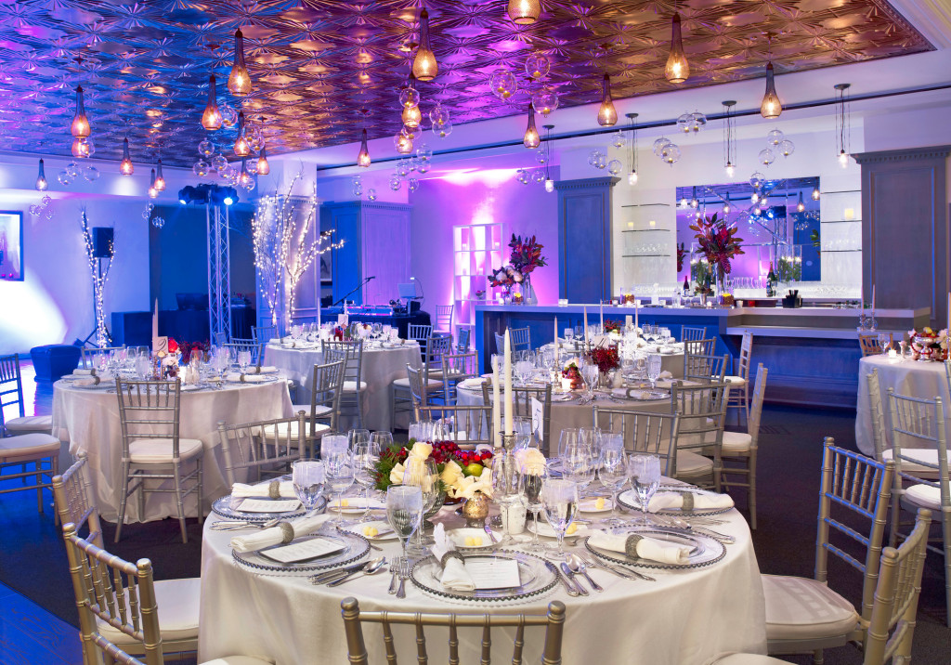

- T Lazy 7:
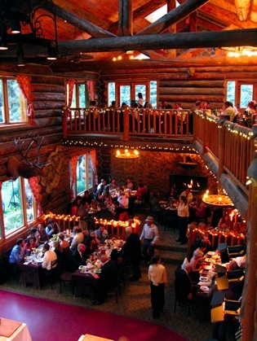
I like this setup. Shown below. Only reception here, no ceremony. Totally different from Hotel Jerome ballroom but still like it.

- Snowmass Club:

Still interested but would like to see pictures of the different venues…or brochure.

- Pine creek Cookhouse:
What do you think of location of this venue? It shows it’s 14miles from city. Would that be an issue?

